**The worldwide leader**

**in light & sustainable construction**

**new façade system**

**ENVEOTHERM ETICS System Earns Prestigious European ETA Certification**

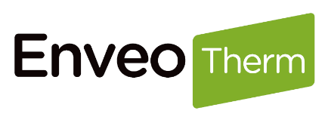**Saint-Gobain launched in first half 2025 new system for facade insulation, which is rooted in expertise, empowered by cutting-edge innovation. EnveoTherm is an external insulation system that combines exceptional performance with versatile design options.**

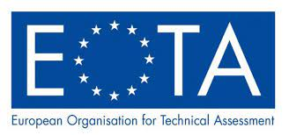Saint-Gobain Eastern Europe, through its leading brand Weber, is proud to announce that its innovative external thermal insulation composite system – **Weber ENVEOTHERM** – has officially received the **European Technical Assessment (ETA)** certificate. This certification confirms the system’s compliance with the highest standards for performance, reliability, and safety, and enables its free use across the entire European internal market.  
**Weber ENVEOTHERM** was launched earlier this year across **11 countries in Eastern Europe**, marking a major step forward in the company’s ambition to deliver cutting-edge façade solutions throughout the region.

**ENVEOTHERM** represents a next-generation solution in facade insulation, combining exceptional thermal performance with aesthetic versatility. Rooted in Saint-Gobain’s decades-long expertise and developed over the past year, the system was independently tested and approved under the stringent ETA procedure – a voluntary path to CE marking for non-standard and innovative construction products.

“The compositions were designed with Saint-Gobain's deep experience in facades and ETICS, as we have been part of the insulation journey from the very beginning,” said **Tomáš Rosák**, CEO of Saint-Gobain Eastern Europe. “ENVEOTHERM emphasizes ease of application, which is key in a market facing a shortage of skilled applicators. It also reflects our commitment to durability, long-term facade cleanliness, and colour stability – especially through the range of our premium renders.”

The **ENVEOTHERM system** comes in two certified lines – **ENVEOTHERM Excellent** and **ENVEOTHERM Premium** – both suitable for residential and commercial buildings, including new developments and renovations. Its modular construction enables the use of different insulation cores, such as mineral wool, white EPS, or graphite-enhanced EPS, while the finishing layer includes a wide choice of silicate and silicone-based renders.

The system comprises **13 tailor-made components**, developed for compatibility and superior performance:

* **6 innovative renders**, including classic silicone and silicate plasters as well as moisture-regulating, pollution- and algae-resistant solutions – available in almost **400 colours** and popular textures.
* **3 versatile adhesives**, optimized for flexibility, ease of use, and compatibility with all insulation types.
* **A high-performance facade primer**, based on silicate-silicone technology, for improved adhesion and water repellence.
* **3 mesh types**, including the revolutionary **3FORCE Mesh** – a **triaxial reinforcement fabric** developed by Saint-Gobain ADFORS, CE-certified under ETA 21/0760. This unique patented solution eliminates the need for diagonal mesh strips and enhances mechanical durability.

“Achieving the ETA certification is the result of intense development and teamwork,” said **Branimir Gogić**, Project Leader for the ENVEOTHERM system. “Our goal was to bring to market a technically superior system that is also highly practical and visually appealing. ENVEOTHERM combines reliability, simplicity in application, and long-lasting façade aesthetics – it’s an all-in-one solution for modern construction.”

The **ETA certificate** provides an independent, transparent, and internationally respected evaluation of ENVEOTHERM’s essential characteristics. It allows Saint-Gobain to apply CE marking to the system and ensures its recognition throughout the EU, EEA, Switzerland, and Turkey – and often beyond.

With Weber ENVEOTHERM, Saint-Gobain continues to lead the way in sustainable building solutions, offering innovations that address real market needs and environmental challenges.

**FIND MORE ABOUT ENVEOTHERM ON** [**WWW.TESTISTHEBEST.COM**](http://WWW.TESTISTHEBEST.COM)

[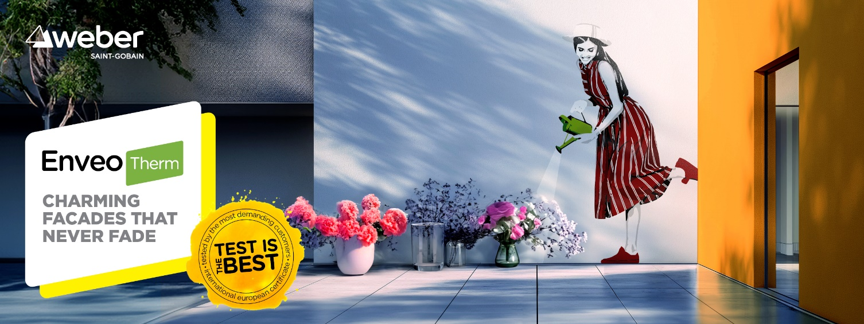](http://WWW.TESTISTHEBEST.COM)

**About Saint-Gobain**

Worldwide leader in light and sustainable construction, Saint-Gobain designs, manufactures and distributes materials and services for the construction and industrial markets. Its integrated solutions for the renovation of public and private buildings, light construction and the decarbonization of construction and industry are developed through a continuous innovation process and provide sustainability and performance. The Group, celebrating its 360*th* anniversary in 2025, remains more committed than ever to its purpose “MAKING THE WORLD A BETTER HOME”.

**€46.6 billion in sales in 2024**

**More than 161,000 employees, locations in 80 countries**

**Committed to achieving net zero carbon emissions by 2050**

**Media contact**

**Jakub Benda**

**Jakub.benda@saint-gobain.com**

(+420) 724 738 135